1a. <https://docs.google.com/document/d/17A3BCosjmdO_zq4zQnyQnjKzpBabYhYN/edit?usp=drive_link&ouid=101220972170142589595&rtpof=true&sd=true>

1b. <https://drive.google.com/file/d/11Gk0jAcNsXIdGMo1a2fajvSvukAHwsR4/view?usp=drive_link>

1c.

Willis Gotama – 2602134954

-Introdcution

-Related Works

-Result and Discussion

-Conclusion

Reinardus Ariel Joan Anandika – 2602119392

-Metodology

-Result and Discussion

-Abstract

-Presentation

Alif Tri Handoyo – Dosen Pembimbing

Edy Irwansyah – Dosen Pembimbing

2a.

1. <https://journal.binus.ac.id/index.php/commit>
2. Research and Technology Transfer Office, Binus University
3. Scope
4. 10/07/2024
5. 7%

2b.

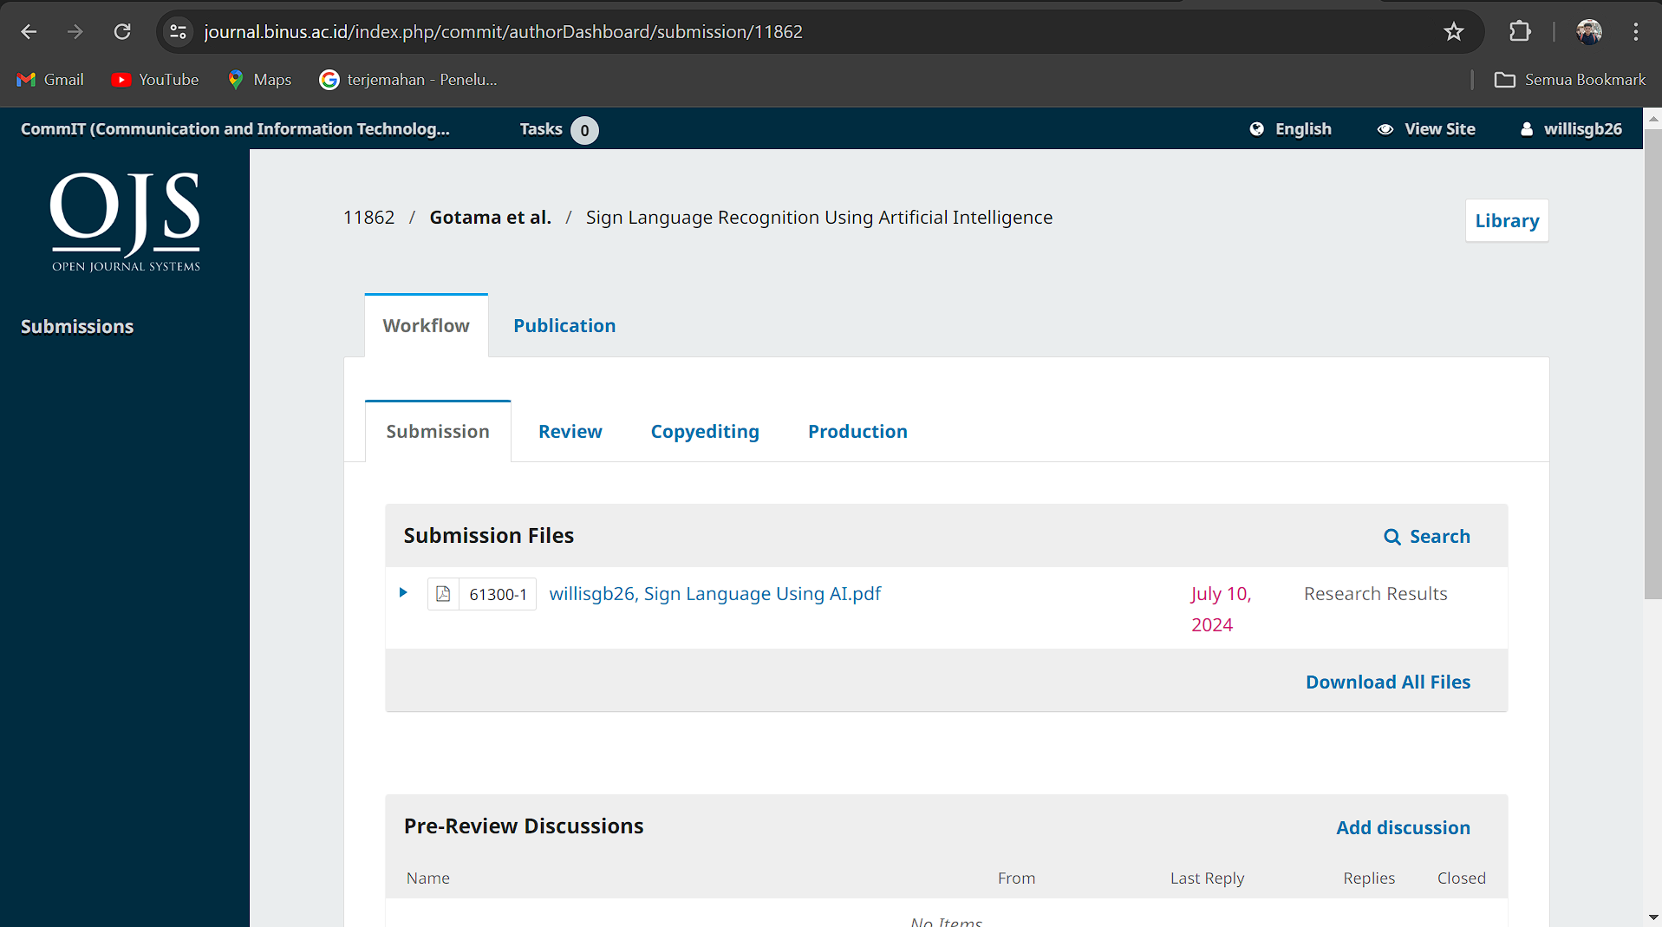

2c.

2d. <https://drive.google.com/file/d/1tu5fIEkI-5I3UyBOVCak-vTgAUm2tCjc/view?usp=drive_link>

3. <https://drive.google.com/file/d/1W9oqlAYpMuC4aNszxYI4vqiH5KYGebrl/view?usp=drive_link>

<https://youtu.be/jcvD9_qB0tU?si=H9BLeR5IYwWD9wWd>

4a.

Presentation

Reinardus Ariel Joan Anandika

* Opening
* Abstract
* Introduction
* Related Works
* Metodology

Willis Gotama

* Result & Discussion
* Conclusion
* Closing

Trailer

Script

Willis Gotama

* "In an ever-evolving world, communication is key to connecting with others. However, not everyone has the same access to communication."
* "But now, AI technology is here to change everything."
* "We started by looking for datasets that would help in this research, collecting thousands of examples of sign languages ​​from around the world."
* "Once the dataset is collected, we process the data in the preprocessing stage, ensuring each data is ready to use."
* "The data is then split into training and test sets, ensuring our model can learn accurately."
* "The model we use is a Convolutional Neural Network, or CNN, which is very effective in recognizing patterns from visual data."

Reinardus Ariel Joan Anandika

* "After several iterations, our model performed satisfactorily, reaching up to 100% accuracy."
* "This proves that AI can help solve problems in society, paving the way for more inclusive communication."
* "This is a major step towards a more inclusive and welcoming world for everyone."
* "With AI, there are no boundaries to communication. Together, we can create a better world."
* "AI for All. The future of communications."

4b. <https://www.canva.com/design/DAGKcJkLG5Q/0vHP4XJu3Z53dg9oIzuA5w/edit?utm_content=DAGKcJkLG5Q&utm_campaign=designshare&utm_medium=link2&utm_source=sharebutton>

4c. <https://drive.google.com/file/d/1DFiq_msgNN3uQM1jdGVsnUTavg9G2XzD/view?usp=sharing>